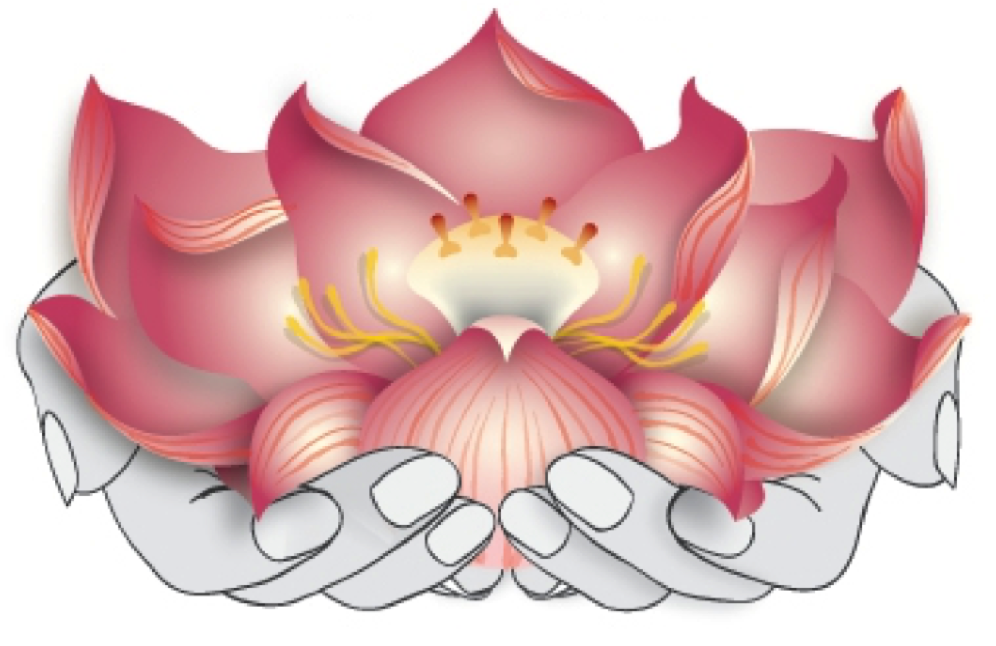

Devata Giving Circle
Membership Form

Our Mission The Devata Giving Circle is a vehicle to empower and engage Cambodian (Khmer) Americans in philanthropy. Along with our friends and allies, we work to promote collaborative giving in order to support organizations working to advance the human rights of Cambodian women and girls.

Our Shared Vision We envision thriving Cambodian communities in which women and girls are healthy, engaged, and empowered to lead.

Our Story To advance and change our society, women and girls must participate at every level of the decision-making process. But for too long, their voices have been silenced, neglected, and unheard.
Having arrived in the United States as refugees since the early 1980s, the majority of Cambodian Americans are survivors of the Khmer Rouge Killing Fields. Coming out of this conflict, the priority has been daily survival. In this environment of transition and struggle, Khmer women and girls face limited opportunities for growth and development.
Devata Giving Circle is changing this reality by strategically investing in Cambodian women and girls. Through our collective efforts, we will inspire our friends and communities and mobilize resources to support dynamic Cambodian American women and girls who will contribute to building vibrant communities. While the challenge is immense, we believe it is a unique and timely opportunity to invest in this initiative. We invite you to invest with us.
Devata Giving Circle is hosted by the Asian Pacific Fund (APF), a 501(c)(3) organization. APF manages our donations and their nonprofit status makes donations to the Devata Giving Circle tax deductible. Devata Giving Circle is a member of the AAPIP (Asian Americans / Pacific Islanders in Philanthropy) National Giving Circle Network.
For questions, please contact us: info@devatacircle.org

Devata Giving Circle
Member benefits include:
o Voting for annual grantees
o Receiving semi-annual newsletters
o Being the first to get involved in signature events and community opportunities
Members will also receive recognition and will be highlighted in our publications and social media.

Membership Level (mark one):
- $100 Professionals and Community Leaders
- $25 Students and Elders

Title (Dr./Mr./Mrs./Miss/Ms./Other):___________

First Name: _____________________________ Last Name: __________________________

Affiliation (if any): _____________________________________________________________

Address:__________________________________________________State: _____________

Zip Code: ____________ Phone: _______________ Email:____________________________

Credit Card (circle one): Visa | Mastercard | American Express | Discover

Name of Card Holder (if different): _______________________________________________

Card Number:________________________________________________________________

Expiration Date: ____________________ CVV: _________________

- Email this completed form to: info@devatacircle.org.

- Pay Membership Donations by check or credit card. Instructions below.
  - To pay by check, make your check payable to Asian Pacific Fund and indicate “Devata Giving Circle, Membership” in the note section of your check. Mail your check to:
Asian Pacific Fund
465 California Street, Suite 809
San Francisco, CA 94101

  - To pay by credit card, go to: https://secure.qgiv.com/for/apfund; select “Devata Giving Circle” from the drop-down list; and include “Devata Giving Circle, Membership” in the “Additional Information” field.

